DYPIEMR(E&TC)

# Dr. D. Y. Patil Pratishthan’s

**DR. D. Y. PATIL INSTITUTE OF ENGINEERING, MANAGEMENT & RESEARCH**

# Approved by A.I.C.T.E, New Delhi , Maharashtra State Government, Affiliated to Savitribai Phule Pune University

Sector No. 29, PCNTDA , Nigidi Pradhikaran, Akurdi, Pune 411044. Phone: 020–27654470, Fax: 020-27656566

Website : [www.dypiemr.ac.in](http://www.dypiemr.ac.in/) Email : [principal@dypiemr.ac.in](mailto:principal@dypiemr.ac.in)

**Experiment No: 5**

**Title:** Verification of Port Characteristics of Microwave Tees.

**Objectives:**

1.To verify the port characteristics of E, H plane Tee.

2.To study the characteristic E-H Planes Tee.

**Apparatus:** Klystron power supply, Klystron with mount, isolator, variable attenuator, Magic Tee, Matched termination, detector mount, CRO, H-Plane Tee, E-Plane Tee.

# Circuit Diagram:

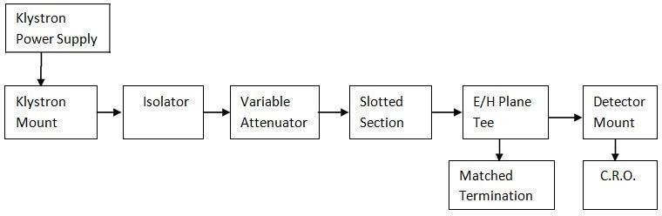

Figure1: Set up for E\H\Magic plane Tee Characteristics.

**Theory:**

**H Plane Tee:**

It is clear from the sketch that an auxiliary waveguide arm is fastened perpendicular to the narrow wall of a main guide, thus it is a three-port device in which axis of the auxiliary or side arm is parallel to the planes of the magnetic field of the main of the main guide and the coupling from the main guide to the branch guide is by means of magnetic fields. Therefore, it is also known as H plane tee. The perpendicular arm is generally taken as input and other two arms are in shunt to the input and hence it is also called as shunt tee. Because of symmetry of the tee; equivalent circuit of H plane, when power enters the auxiliary arm, and the two main arms 1 and 2 are terminated in identical loads, the power supplied to each load is equal and in phase with one another. If two signals of equal amplitude and in same phase are fed into two main arms1 and 2, they will be added together in the side arm. **Thus, H plane tee is an ‘adder’.**

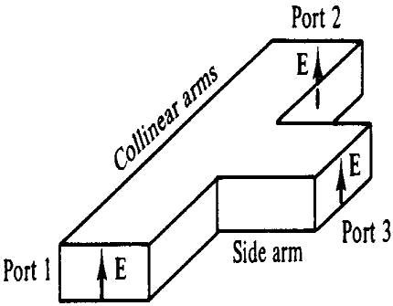

**E Plane Tee:**

It is clear from the sketch of the E plane tee that an auxiliary waveguide arm is fastened to the broader wall of the main guide. Thus, it is also a three-port device in which the auxiliary arm axis in parallel to the plane of the electric fields of the main guide, and the coupling from the main guide to the auxiliary guide is by means of electric fields. Therefore, it is also known as E plane tee. It is clear that it causes load connected to its branches to appear in series. So, it is often referred to as a series tee. As indicated in fig, the two main guide arms are symmetrical with respect to the auxiliary guide arm. As such if power is fed from the auxiliary arm, it is equally distributed in the two arms 1 and 2 when they are terminated in equal loads. However as depicted in the field configuration, the power flowing out in arm 1 is 180 out of phase to the one in arm 2. **As such tee is known as ‘subtracter’.**

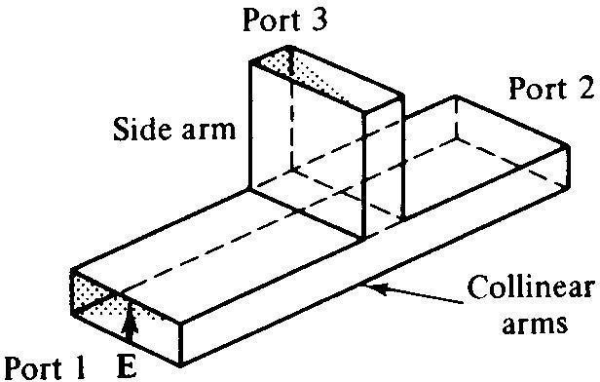

**Magic Tee:**

An interesting type of T junction is the hybrid tee, commonly known as ‘magic tee’ which is shown in fig. The device as can be seen from fig is a combination of the E arm and H plane tees. Arm3, the H arm forms an H plane tee and arm 4, the E arm, forms an E plane tee in combination with arms 1 and 2. The central lines of the two tees coincide and define the plane of symmetry, that is, if arms 1 and 2 are of equal length, the part of structure on one side of the symmetry plane shown by shaded area is the mirror image of that on the other. Arms1 and 2 are sometimes called as the side or collinear arm.

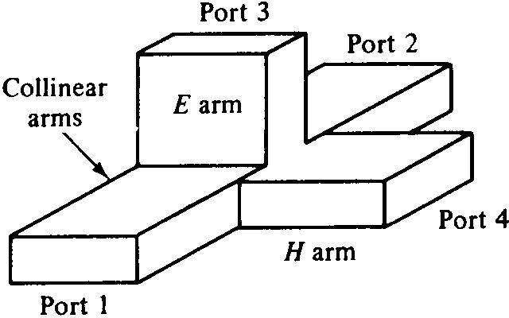

**Magic of the MAGIC Tee:**

The name is given because the way in which power divides among the various arms of Magic Tee. If power is fed into arm3, the electric field divides equally between arms 1 and 2 and the fields are in phase. Because of symmetry of the T junction, no net electric field parallel to the narrow dimension of the waveguide is excited in arm 4. Thus no power is coupled in port 4. Reciprocity demands no coupling in port 3 if power is fed in 4.Another property that results from the symmetry of the junction is, if power is fed in E or H arm, it is equally divided between arms 1 and 2. Further, magic tee being combination of E and H plane tees, if power is fed from arms 1 and 2, it is added in H arm (3) while is subtracted in E arm (4). A simple E-H tee has disadvantage of not being matched when seen from E and H arms when side arms are terminated in matched loads. The VSWR being > 2 the most commonly used method to reduce VSWR is to introduce discontinuity such as port iris in or near T junction to cancel out reflections occurring there in.

**Procedure:**

1. Connect the component as shown in the figure 1.

2. Connect the E plane, H Plane to the test bench and apply the input at 1 port and terminated another port with matched termination and observe the output to the ports as mentioned in the observation table.

Note down the port inputs and outputs.

**Observations**:

Repeller voltage:

Beam voltage:

Beam current:

**Conclusion:**

**Questions:**

1. Explain the properties of H-plane Tee using s-matrix.
2. Derive the S matrix of Magic Tee & Explain in detail any two application of Magic Tee.
3. State and explain the properties of S parameters.

**References:**

1.M. Kulkarni, “Microwave and Radar engineering”, 3rd edition, Umesh Publications 2.M L Sisodia& G S Raghuvanshi, “Basic Microwave Techniques and Laboratory Manual”, New Age International (P) Limited.